

PRE-BOARD EXAMINATION AUGUST 2022
Bachelor Level/First Year/I Semester Full Marks: 60
Computer Science and Information Technology Pass Marks: 30
Subject: Digital Logic (CSC111) Time: 3 Hours
Examination Date: 22st August, 2022

Candidates are required to give their answers in their own words as for as practicable.
The figures in the margin indicate full marks.
SET B
Group ‘A’
(Long Answer Question Section)
Attempt any TWO questions. (2x10=20)
- Implement the following function F=Ʃ(0,1,3,4,8) using
a) Decoder
b) Multiplexer
c) PLA
- Differentiate between synchronous and asynchronous sequential circuits. Design a counter as shown in the state diagram below.
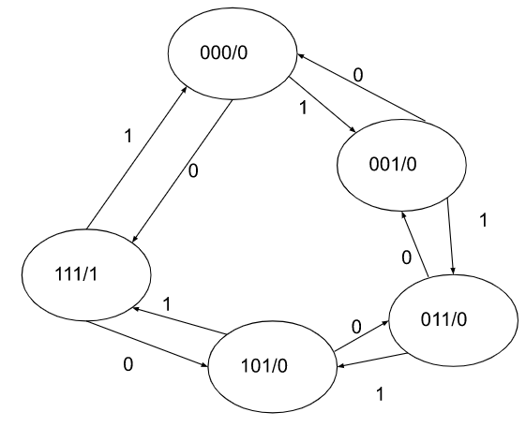
- Differentiate between ring counter and twisted ring counter.

Group B
(Short Answer Question Section)
Attempt any EIGHT questions. (8x5=40)
- Convert (BCFF)16 to decimal, octal and binary.
- What do you mean by decoder? Design 3 to 8 decoder.
- Design 3-bit binary ripple up counter.
- Design 3 bit magnitude comparator.
- Design BCD adder.
- Design a 3-bit even parity generator?
- Use K-map to simplify the given function in SOP. Implement using AND and OR gates.
- What do you mean by triggering a flip flop.
- Write short notes on:
  - State Reduction
  - Integrated circuits.

*THE END*

